Design and Implementation of Portable Smart Wireless Pedestrian Crossing Control System
Alternative title: Accurate detection rate and the localization accuracy using deep learning for Pedestrian
Aim:

To improve the Pedestrian detection rate and the localization accuracy using Cascade Compact CNN.
Synopsis:
Pedestrian detection has made significant advances benefiting from the region-based convolutional neural networks (R-CNN). The project introduces a strict matching metric, which is beneficial to selecting well-aligned positive samples A positive sample matches a ground truth only if all its region-IoUs are bigger than a threshold. Secondly, an improved negative example selection strategy using both the classification and localization information is proposed to mine hard negative examples, which can further suppress the false positive detections near the pedestrians.
Existing System:
Existing system incorporates the concept of smart sensing to detect the presence of pedestrians and in turn, automatically controls the crosswalk traffic lights. The system composes of two Arduino microcontrollers, two infrared PIR motion sensors, and a bidirectional wireless communication link based on Bluetooth for mitigating wiring installation and transmitting the signal among traffic light units on both roadsides. The system is fabricated and implemented as a portable LED-based traffic light testbed.
Proposed System
A cascade compact convolutional neural network (CC-CNN) is proposed for accurate pedestrian detection. CC-CNN based detector can effectively improve the detection rate and the localization accuracy using fewer parameters.

Module List:
- Region-IoU
- CNN for Pedestrian Detection

Module Description:

Region-IoU

In previous works of R-CNN based object detection, a proposal bounding box b= (bx,by, bw, bh) and a ground truth bounding box g= (gx, gy, gw, gh) match if they overlap sufficiently. Here, (bx, by, bw, bh) is the top-left corner, the width and height of the bounding box. Specifically, they employ the measurement proposed by PASCAL challenge.

Cascade Compact CNN for Pedestrian Detection

A cascade compact CNN framework is proposed to improve the detection rate and the localization accuracy of the pedestrian detection.

Requirements:
Software Requirements:
- Language : Python
- Compiler : GCC Complier
- OS : Linux
Hardware Requirements:
- Raspberry pi
- USB Camera
- Traffic signal LEDs

Block Diagram:
GPIO Pins
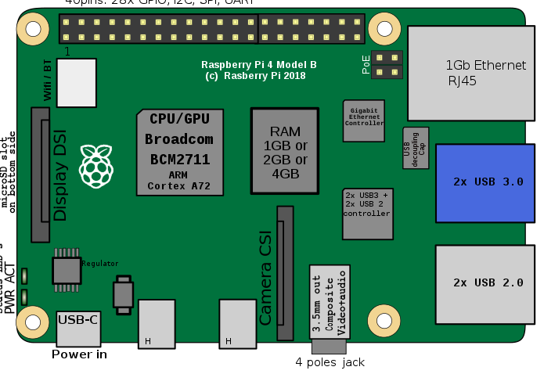
Raspberry pi 4

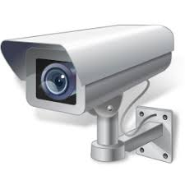
Traffic camera
Traffic Signal
USB port

Block Diagram Description:
In this project, Raspberry pi act as main controller and USB camera, Traffic light connected to it. Raspberry pi is a miniature computer can perform image processing and ability to run machine learning algorithms. When camera sends the live video feed, it receives the image frames and fed into the CNN model to detect the presence of pedestrians. If any pedestrian detected, Raspberry pi change the signal to Red.

Architecture Diagram:

